 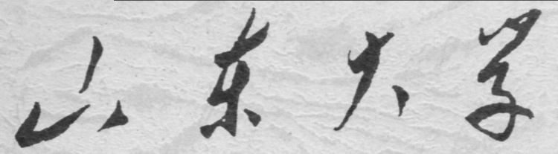

**崇新学堂**

**2022－2023学年第一学期**

实 验 报 告

课程名称： EECS

实验名称： Design lab 4

专 业 班 级 21级崇新学堂

学 生 姓 名 余昊 葛明烨 崔宇鑫

实 验 时 间 10月8日

**Step1：**

**Introduction**

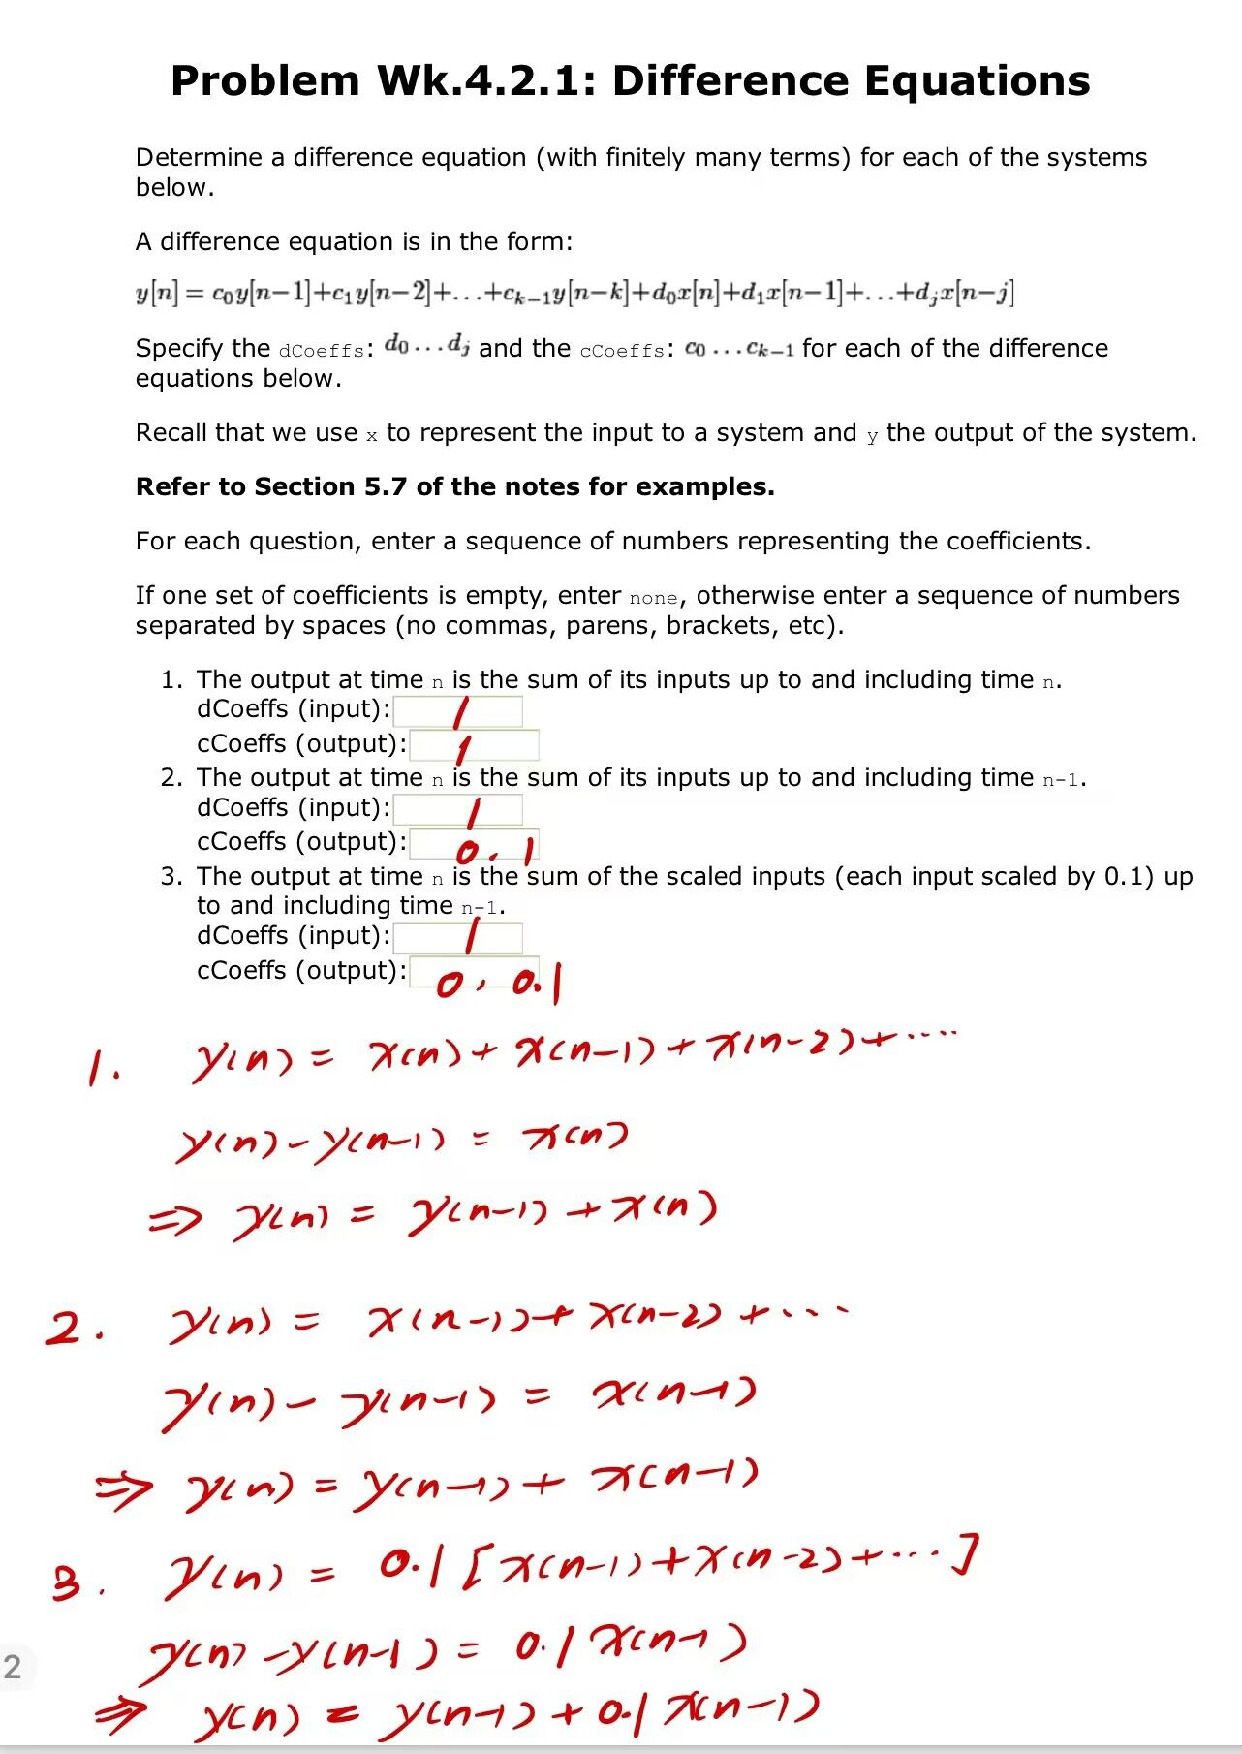 **The first step is a guide to "difference equation", which requires us to build specific difference equation models for different instances. For WK.4.2.1, the difference equation we established and the correlation coefficient of the difference equation are shown in the figure below.**

**Step2：**

**Difference equations for wall finder**

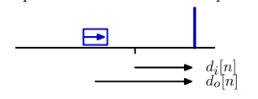

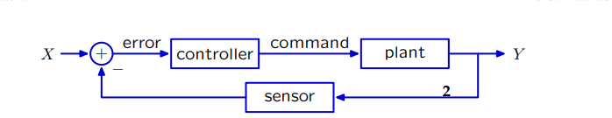 **图一**

**图二**

**In the second step, our task is to establish the difference equation of the actual physical model. The final goal is to make the car stop at a certain distance from the wall, and the focus is on how to use the difference equation to connect multiple discrete measurement values.** **For the robot shown in the figure above, we first need to make clear the actual physical meaning of each discrete variable: do[n] represents the distance between the current robot and the wall, and di[n] represents the distance between the location where we want the car to stop and the wall. (Note: di[n] is the system input and do[n] is the system output.)** .**V[n] is the speed of the car at time n, and we assume that the car will maintain this speed until it receives the next command at time n+1. T is the time interval over which the measurements are discretized.**

***Check Yourself 1.***

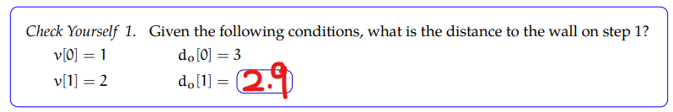

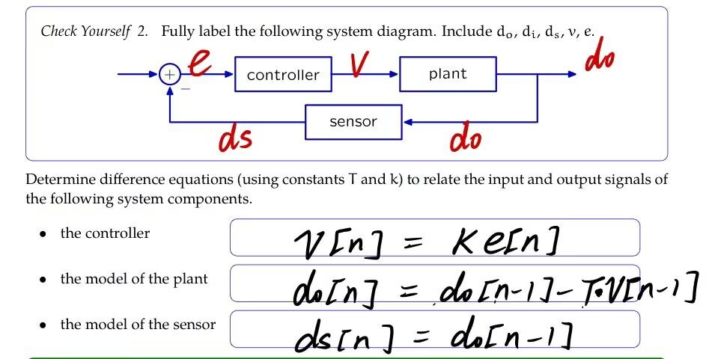***Check Yourself 2.***

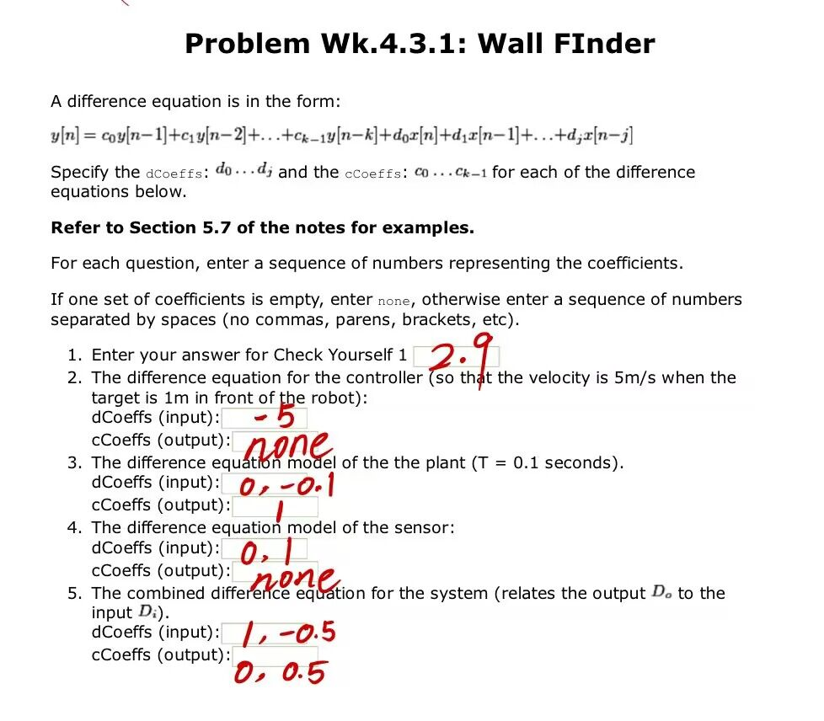**Wk.4.3.1**

**According to the connection structure of the control system and the internal structure of the subsystem, if the input-output relationship is expressed as operator equation, the following results can be obtained: Do=·Di**

**Convert operator equaion back to the difference equation:**

**Do[n]=Do[n-1]-T*K*(Do[n-1]-Di[n-1])**

***Checkoff1***



*The explanation and analysis of* ***Check Yourself1***:

**The physical model has been simplified appropriately in Check Yourself1. We assume that the robot changes its speed instantaneously upon receiving a command and maintains this speed until it receives the next command. Therefore, the output of the robot in the next step do 'is equal to the output of the current step do minus the rate of the robot in the current step times the interval time of the step:**

**do[0]-do[1]=v[0]*T, （T=0.1）**

*The explanation and analysis of* ***Check Yourself2:***

**In FIG. 2, the structure of a control system is established. Obviously, the controller and plant are cascaded structure, while the sensor is the negative feedback introduced by the system.**

**The subsystem is as follows：**

Controller：**The output of the system is a value which represent the V, the input of the system is ‘error’(The net amount of input).So the Controller system is actually a multiplier that amplifies the input signal by a factor of K to get a desired speed value V.**

**The difference equations of this model : V**[n]=-5*e[n]

Plant：**The output of the system is the distance Do from the current position of the robot to the wall, and the input of the system is the speed value V output by the controller. The relationship between Do and speed V satisfies a difference equation in *Check yourself1.***

**The difference equations of this model:** d0[n]=do[n-1]-T*V[n-1]

Sensor: **The input of the system is the output Do of the total system, and the output of the system is actually a delay signal to Do. The sensor acts as a negative feedback network in the whole system, while the sensor system itself is just a simple delay device.**

**The difference equations of this model:** ds[n]=do[n-1]

Wall-finder system：**We connect all subsystems according to the relation shown in the structure diagram to obtain the difference equation of the wall-finder system**：

do[n]=do[n-1]-T*K*(di[n-1]-di[n-2])

*The explanation and analysis of* ***WK.4.3.1***

**To obtain the cCoeffs and dCoeffs required by each question in WK.4.3.1, we just need to transform the difference equation into a standard form and put in specific parameters.**

**As for the transformation of operator equation and difference equation:**

**We convert some variables to operators acting on inputs or outputs，We can directly change the form of the difference equation to get operator equation, or draw a block diagram of the system, and express the relationship between the output signal and the input signal through various arithmetic machines.**

**Step3：**

**State machines primitives and combinators**

***Check Yourself 3.***

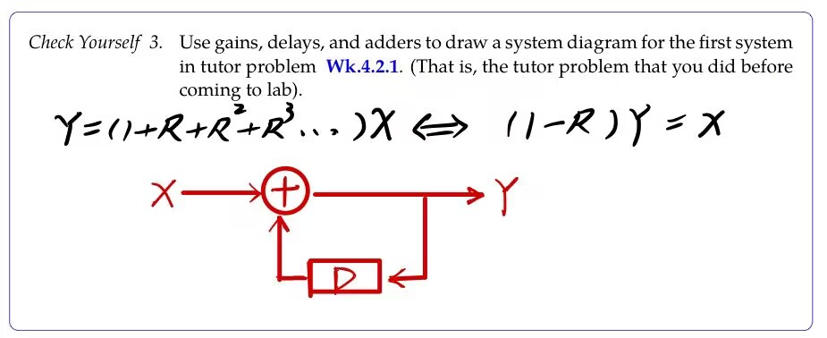

***Check Yourself 4.***

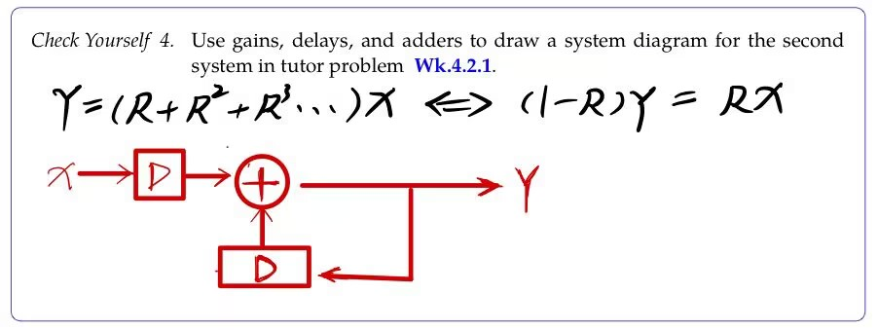

***Check Yourself 4.***

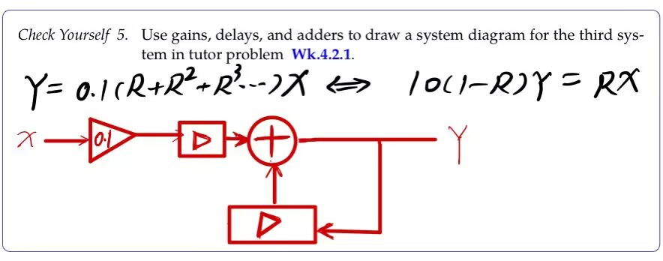

**WK.4.3.3**

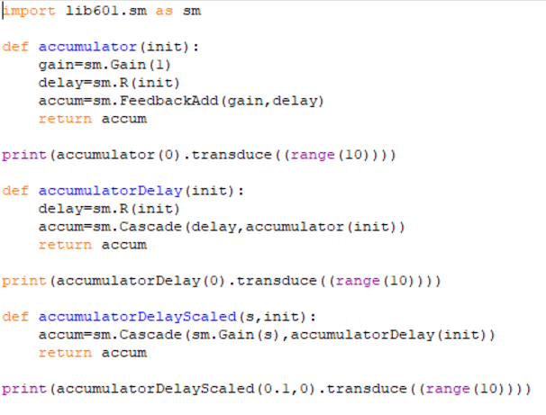

***Check Yourself 6.***

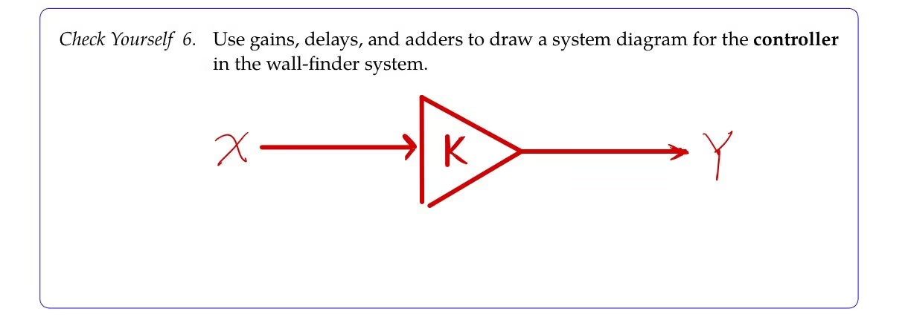

***Check Yourself 7.***

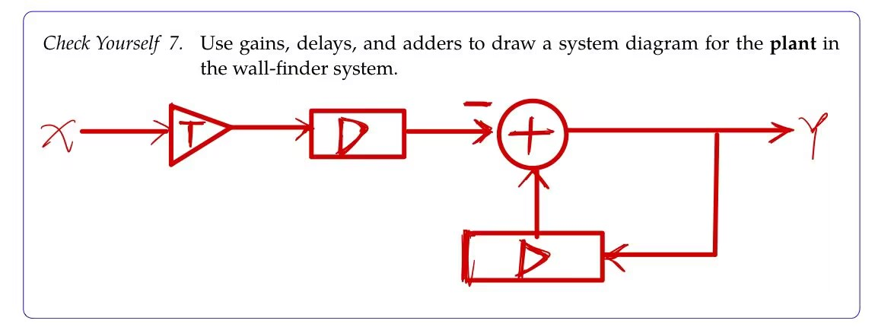

***Check Yourself 8.***

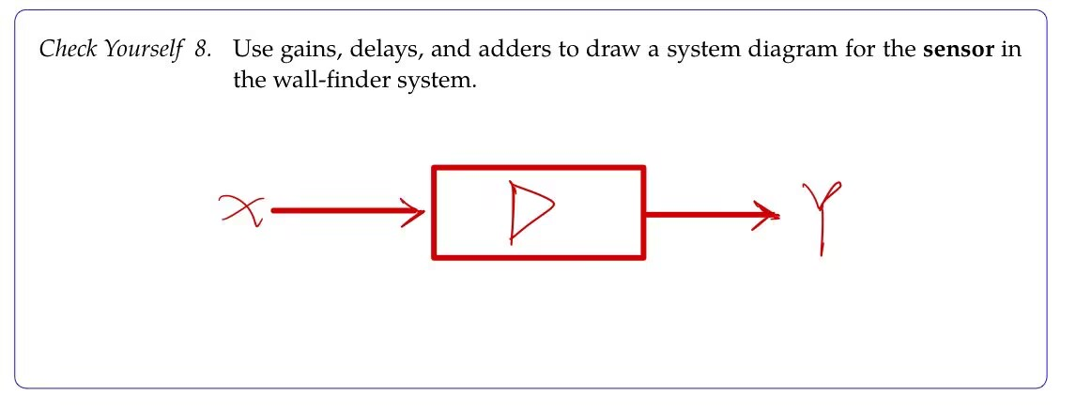

***Check Yourself 9.***

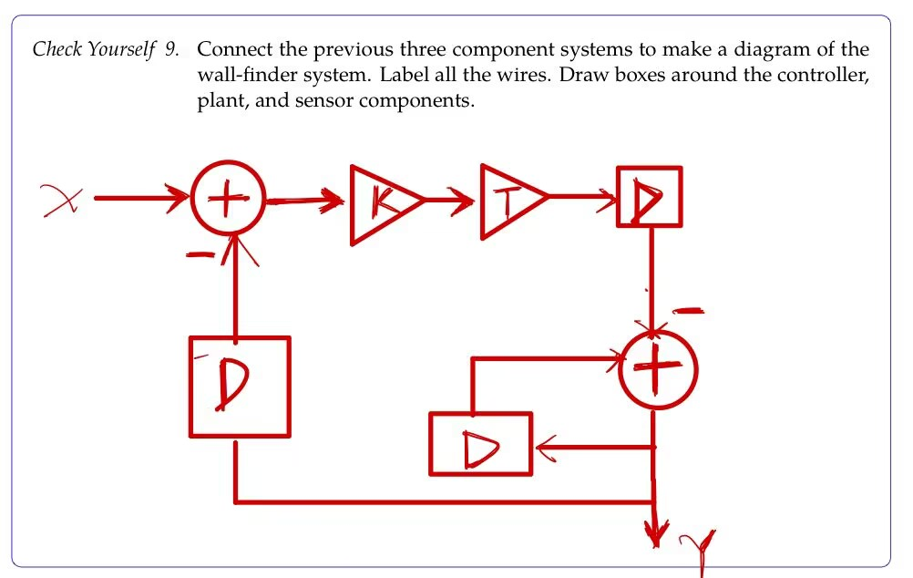

**WK.4.3.5**

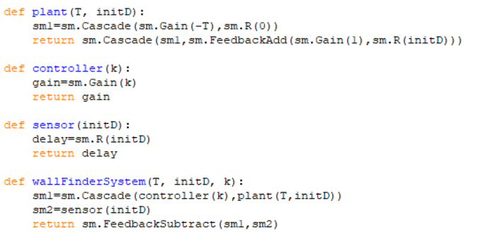

***Check Yourself 10.***

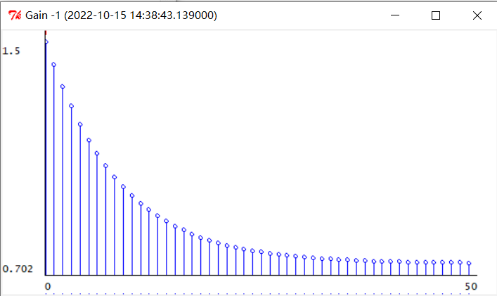

**图1（k=1）**

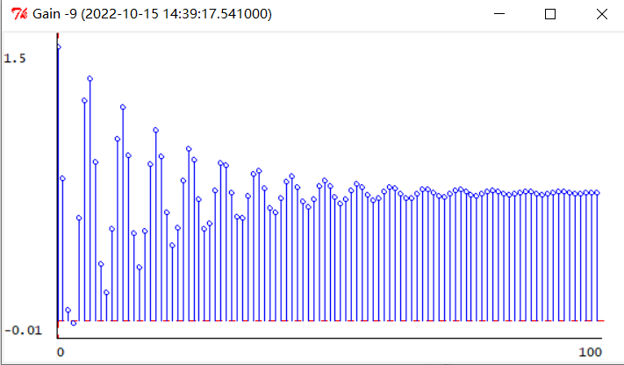

**图2（k=9）**

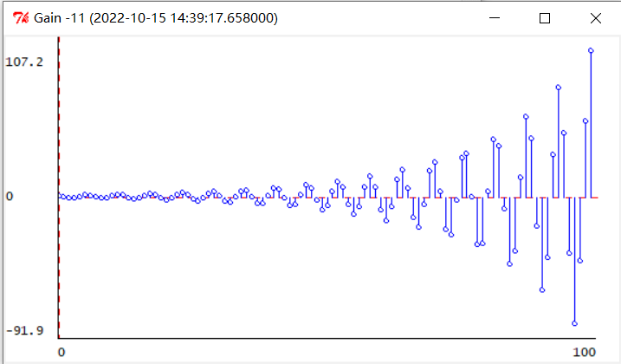

**图3（k=11）**

**WK.4.3.6**

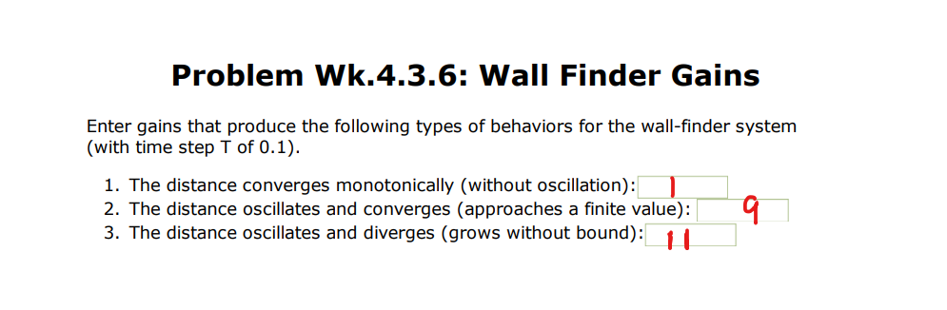

***Checkoff2***

*The explanation and analysis of* ***Check Yourself3:***

**The block diagram of this operator equation contains an adder and a Feedback network，The feedback network is a unit delayer, so as to achieve the accumulator effect.**

*The explanation and analysis of* ***Check Yourself4:***

**The block diagram of this model can be directly improved on the basis of the block diagram of *Check Yourself3*. As accumulator needs to accumulate to X[n-1] instead of X[n], a unit delay accumulator is added at the input end to delay the input X by one unit before input to the whole system.**

*The explanation and analysis of* ***Check Yourself5:***

**The block diagram of this model is also changed on the block diagram in check yourself4, which requires adding a multiplier in the input segment to achieve the proportional scaling of the input signal.**

*The explanation and analysis of* ***WK.4.3.3:***

**In WK.4.3.3, python is used to establish the above three operator equation functions. We need to use the sm module in lib601 library for the relationship between the computers.**

The following figure shows a block diagram of *FeedbackAdd*

**In the figure, m1 and m2 represent state machine instances. The first parameter of sm.FeedbackAdd corresponds to m1 and the second parameter corresponds to m2**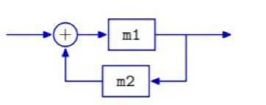

accumulator：**The return value of the function is an instance of sm.FeedbackAdd.m1 should be an instance of sm.Gain in this function. sm.Gain functions as a multiplier, and the output is K times the input. In this function, let K=1, indicating that the output is equal to the input.**

**m2 is an instance of sm.R, which plays the role of unit delay.** accumulatorDelay: **The return value is an sm.Cascade instance. The first argument of the sm.Cascade instance is the unit delay (an instance of sm.R), and the second argument is the *accumulator* which is a function we just defined.**

accumulatorDelayScaled：**The return value of the function is also a sm.Cascade instance. By using the function defined above, directly cascade a multiplier (the instance of sm.Gain ) with accumulatorDelay function to scale the input by k times**.

*The explanation and analysis of* ***Check Yourself6，Check Youself7 and Check Yourself8:***

**In step2, we have established the difference equation model of controllor, plant and sensor subsystems, and directly transformed the difference equation into operator equation:**

controllor：Y=KX

plant: Y=RY-TRX 🡪 Y=

sensor:Y=RX

Wall-finder system: Y=·X

*The explanation and analysis of* ***WK.4.3.5***

*(Build wall-finder system in python):*

**According to the block diagram and operator equation:**

Controller:**Returns an instance of sm. gain. The parameter K is the scale of the input**

Plant: **Returns an sm.Cascade instance. The first argument is also a Cascade instance to cascade a multiplier and unit delay, and the second argument is a feedback adder.**

Sensor: **Returns an instance of sm.R that represents the role of the unit delayer**

Wall-finder system: **As a whole, the system is a feedback adder. For the first parameter m1 state machine of the sm.FeedbackAdd instance, it is the cascade of the controller return value and the plant return value, and the second parameter m2 state machine is the sensor return value.**

*The explanation and analysis of* ***Check Yourself10***:

**QUESTION: The relationship between k value and the final distance of the robot from the wall.**

**We first analyze qualitatively, and the k value first affects the speed of each step robot. When k is small, the robot will eventually stabilize at d0 away from the wall, and the speed of the robot decreases gradually in the process of movement. Therefore, the image of do-n (n is the sampling point) should be a single subtraction concave function, which tends to be flat. When k is relatively large, we can imagine that the robot will definitely jump di in a certain step. At this time, according to the difference equation, the speed will be reversed. If the distance of the robot from the wall is greater than di in the next step, the robot will move forward again, and so on.**

It's an oscillatory process, but does the robot end up at exactly di? It depends on the size of k.

**do-n images are observed in the program by changing the value of k each time. We found three k values, k=1, k=9 and k=11, which correspond to three cases of monotone convergence, oscillation convergence and oscillation divergence respectively.**

**Step4**

**On the simulated robot**

**The task in Step4 turns to control the actual tracking movement of the car, and debugging through simulation**

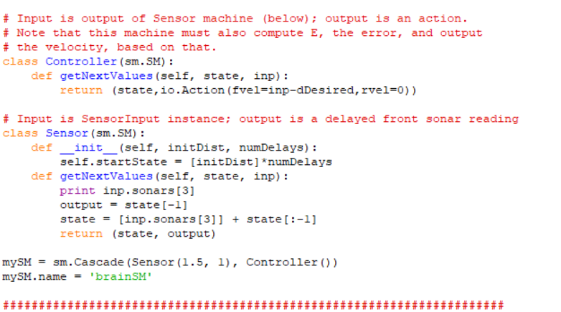**Class definition in python:**

***Check Yourself 11.***

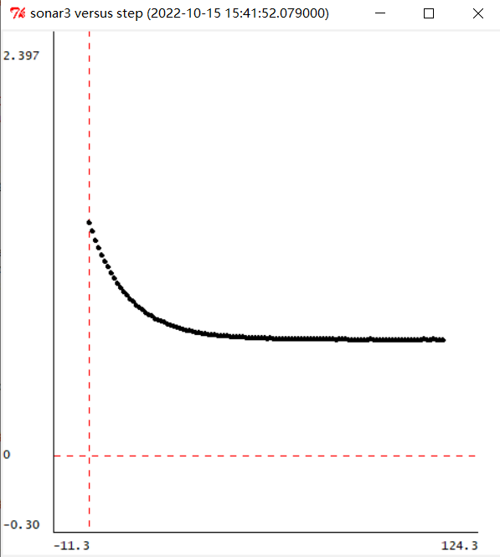

**(k=-1)**

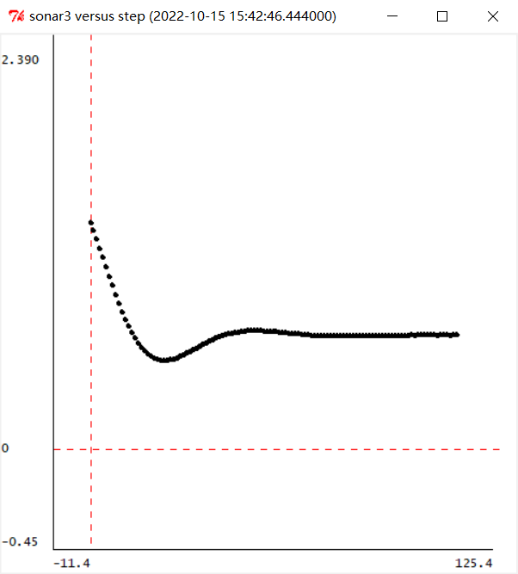

**(k=-9)**

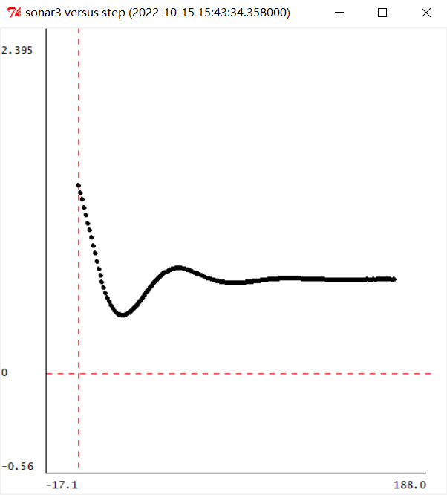

**(k=-11)**

***Checkoff3***

**Compare the image in Check yourself10 and Check yourself11:**

**When k=1, both images converge monotonically,**

**When k=9, although both images are oscillatory convergence, it is obvious that in check yourself10, the amplitude of image oscillation is larger and the frequency of oscillation is higher.**

**When k=11**，**The image in check yourself10 is oscillating and diverging while the image in check yourself11 is oscillating and converging.**

***Analysis:***

**From the perspective of program parameter adjustment：**

**（Increasing the value of k in units of 1）**

**By comparing the difference of the images, it can be concluded that the k range in check yourself11 is greater than that in check yourself10 when the image converges.** 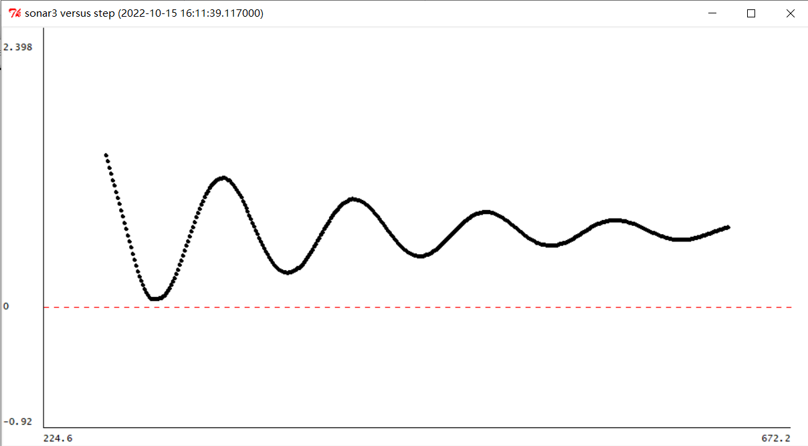

**（k =-18）**

**When k=18, the image still oscillates and converges. Continue to increase the value of k, the car will hit the wall in the simulation mapIf the car hits the wall on the simulation map, the image cannot be drawn effectively, but it can be predicted that the K value of image divergence will be much larger than that in check yourself10.)**

**From the theoretical level:**

**Let's go back to our original difference equation model:**

**d**o[n]=do[n-1]-T*V[n-1]

**The operator equation**：Do=·Di

**After replacing R by 1/z, we can find the poles analytically**

**:**

**The roots of this polynomial**：

**When the system converges, the absolute value of the extreme point is less than 1, modulo less than 1 for the complex number.**

**Therefore,In check yourself10 (T=0.1) :**

**when k>0, the system diverges monotonically;**

**when -2.5 >k>-10 ,** **The system oscillates but converges.**

**When k < -10, The system oscillates and diverges**

**But in check yourself11：The interval T between adjacent detection values of the car's sensor is less than 0.1, so the k value of the critical point of convergence and divergence of the system is smaller than -10. Therefore, when k=-11, the image in *check yourself10* diverges while the image in *check yourself11* does not diverge.**

**Summary**

1. **Through the study of this experiment, I have experienced how to establish a simple difference equation model and operator equation of a discrete system. When faced with a more complex discrete system, a very important point is to use the PCAP thought, will be a discrete system as the combination of several simple subsystem, make sure the function of each subsystem in complex system, establish a subsystem model of internal structure, between different subsystems to build the connection between the input and output, Find the connections between subsystems, such as cascade, parallel, feedback, etc., and finally integrate subsystems into complex systems. At the same time, the idea of PCAP is also reflected in how to abstract a real physical model, and through appropriate simplification, the physical quantity is abstracted into measurable and computable discrete variables.**
2. **In the experiment of step3, check yourself10 requires us to get the image of do-n under three k values, but the following error occurs when the plotD function in designlab04work.py is called:**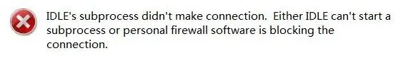

**We checked the code several times and found no grammatical or logical problems. We also considered whether the library file was missing, so we re-installed the lib601 library file, and found that the problem was still not solved.Finally, we searched the "Subprocess Startup Error" in the error prompt online and found a solution:**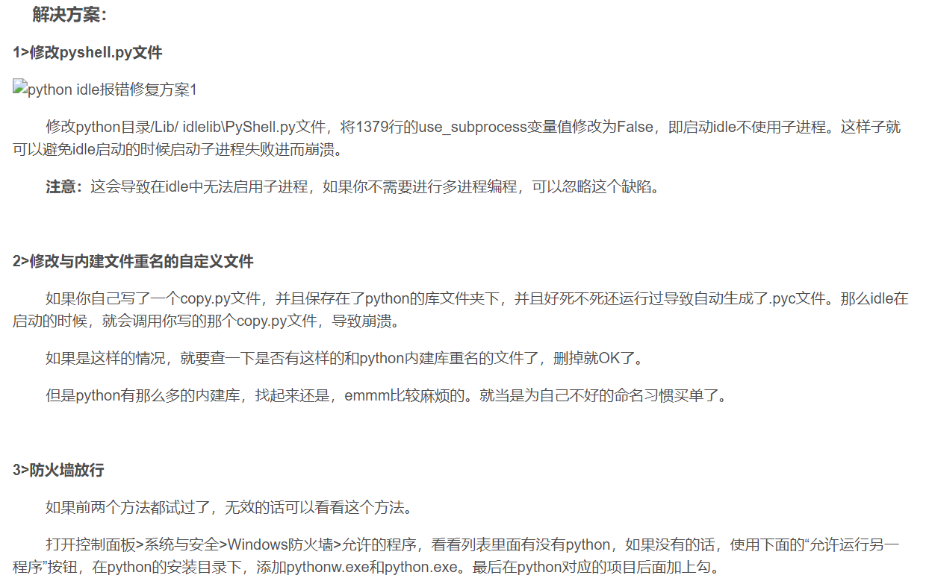

3. **In step4, it is required to analyze the reasons for the different convergence of the drawn images with the same k value in check yourself10 and check yourself11, which is a difficult point in the experiment. This needs to start from the principle, back to the theoretical level of thinking** .Y=·X **Represents the relationship between the input quantity and the output quantity in the wall-finder system.After consulting relevant theoretical data, we learned that** **Representative system function**，**For a system function, we can find the zeros and poles of the system function. The method of finding the pole is also a difficult one. The method is to find the zero of the z polynomial by setting 1/z=R. The convergence and divergence of system functions depend on the size of poles, so we find the range of k under critical conditions from the principle formula, which is a physical quantity related to T. Therefore, it is the difference in T between adjacent steps of the system that leads to the difference in convergence for the same value of k.**

**实验报告要求：**

1. **上面为实验报告的电子模板；**
2. **根据实验讲义，记录各个步骤（Step）需要记录的关键内容、实验结果、仿真结果（比如仿真截图，测试代码IDLE运行结果等）、实验结论、遇到的问题及解决方案等，简单记录即可，按照讲义的实验思路一步步完成，可以类似于实验LOG的书写。课下准备实验以及实验室做实验过程中可以边做边写，没有什么需要记录的Step可以略过；**
3. **实验讲义中的Check Yourself和Checkoff需要在报告中完成；**
4. **系统框图、数据表格等请记录清晰，公式使用公式编辑器输入，需要展示的程序片段可以复制粘贴或者截图；**
5. **最后总结部分（Summary）写一写实验总结和心得，遇到的问题和解决方案等；**
6. **实验报告内容推荐使用全英文书写，不好记录或者表述的中英文结合或者中文也可以。**